**TASK 8 , DATE = 19/1/25**

1. Query the sum of *Northern Latitudes* (*LAT_N*) from STATION having values greater than 38.7880 and less than 137.2345. Truncate your answer to  decimal places.

Input Format. The STATION table is described as follows:

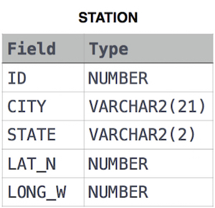

where *LAT_N* is the northern latitude and *LONG_W* is the western longitude.

**Solution:**

SELECT ROUND(SUM(LAT_N),4) AS sum_lat

FROM STATION

WHERE LAT_N > 38.7880 AND LAT_N < 137.2345;

1. Query the greatest value of the *Northern Latitudes* (*LAT_N*) from **STATION** that is less than . Truncate your answer to 137.2345 decimal places.

**Input Format.** The **STATION** table is described as follows:



where *LAT_N* is the northern latitude and *LONG_W* is the western longitude.

**Solution:**

SELECT ROUND(MAX(LAT_N),4) AS max_lat_n

FROM STATION

WHERE LAT_N < 137.2345;

1. Given the **CITY** and **COUNTRY** tables, query the sum of the populations of all cities where the *CONTINENT* is *'Asia'*.

**Note:** *CITY.CountryCode* and *COUNTRY.Code* are matching key columns.

**Input Format.** The **CITY** and **COUNTRY** tables are described as follows:

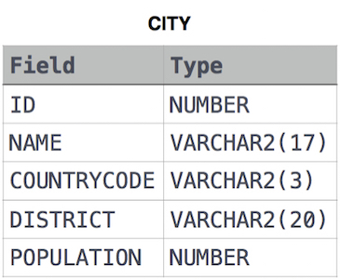

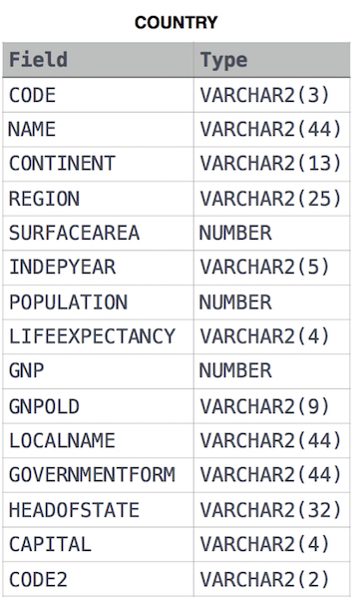

**Solution:**

SELECT SUM(ci.POPULATION)

FROM CITY AS ci

JOIN COUNTRY AS co

ON ci.COUNTRYCODE=co.CODE

WHERE co.CONTINENT='Asia';

1. **Given the CITY and COUNTRY tables, query the names of all cities where the *CONTINENT* is *'Africa'*.**

**Note: *CITY.CountryCode* and *COUNTRY.Code* are matching key columns.**

**Input Format. The CITY and COUNTRY tables are described as follows:**





**Solution:**

SELECT ci.Name

FROM CITY ci

JOIN COUNTRY co

ON co.code = ci.countrycode

WHERE CONTINENT ='Africa'